# User Manual

Table of Contents

Home Screen 2

The Login screen 2

Dashboard 3

User and Role management 3

Show Details 4

Add more roles 4

Edit Roles 4

Delete roles 5

Table Maintenance 5

Setup companies 6

Manage contracts 7

Setup Contact persons 8

Manage Position Tile 9

# Home Screen

Explore by clicking any of the links menu

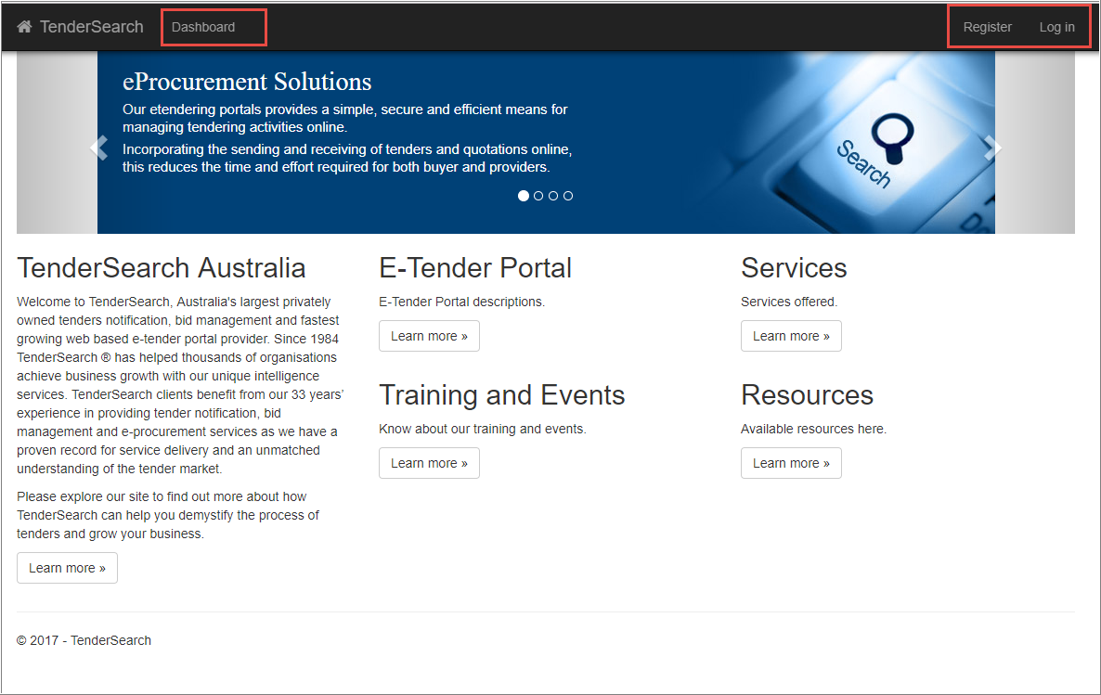

# The Login screen

Only authorized users can access the Dashboard.

Anonymous users can self-register using the “Register” link.

Anonymous users cannot assign roles to themselves after registration. This is where the UsersManagers comes in. (see the Dashboard section for more details)

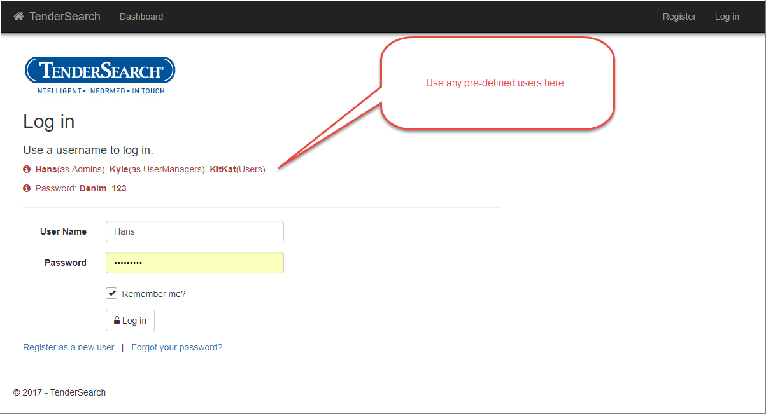

# Dashboard

After a successfully log-in, you will be directed to the dash board IF you have multiple roles.

In this case, Hans is an Admin and have been pre assigned with 3 different roles. If only 1 role is assigned, Dashboard will not be accessible and the user will go directly to its intended web page.

Try this using Kitkat as the user.

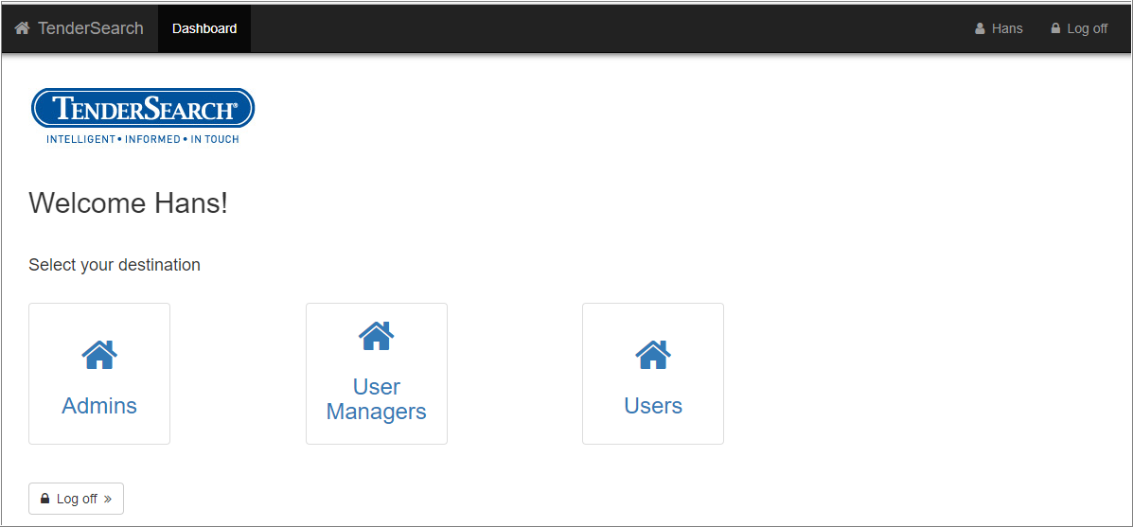

# User and Role management

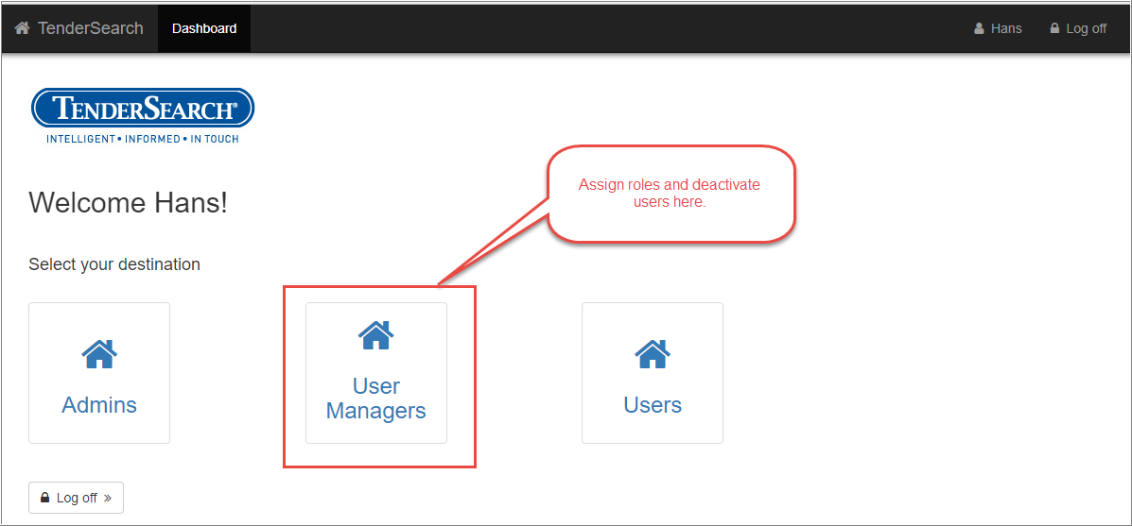

## Show Details

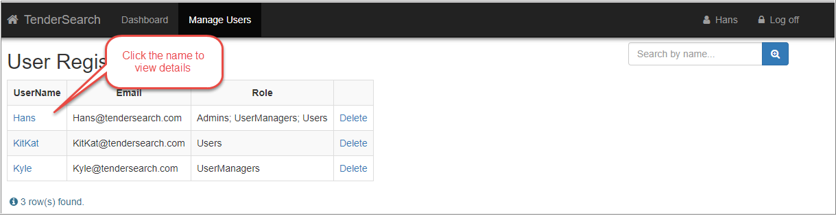

## Add more roles

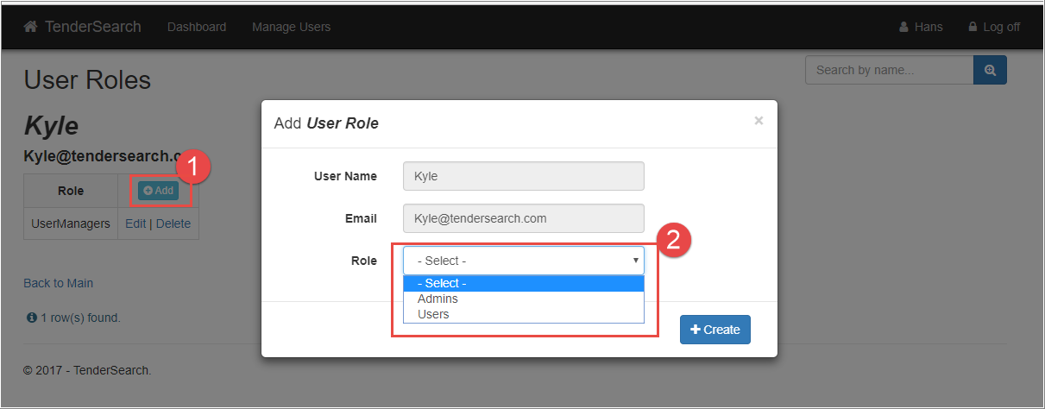

## Edit Roles

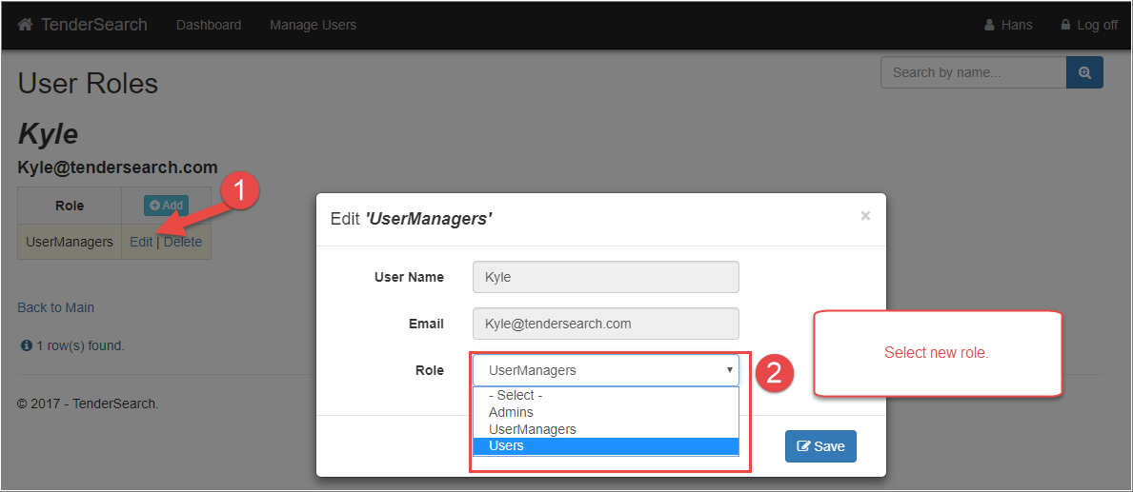

## Delete roles

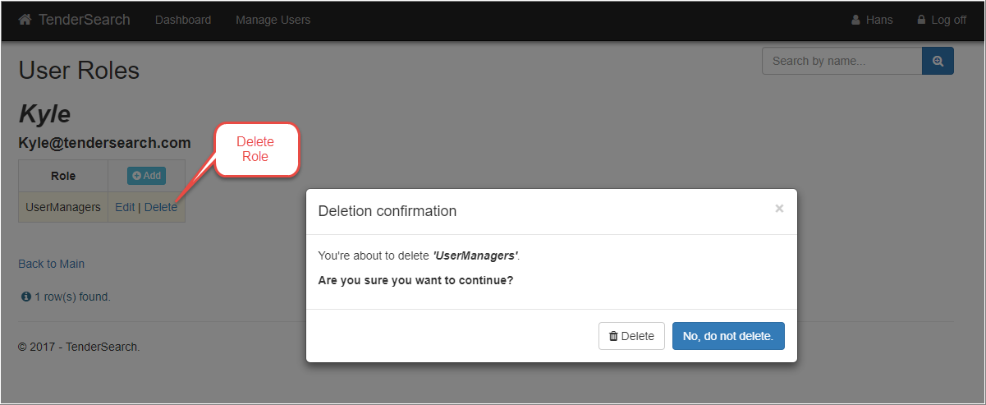

# Table Maintenance

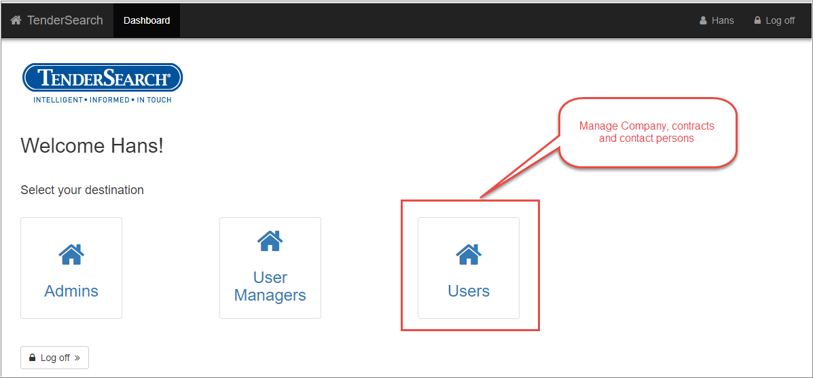

## Setup companies

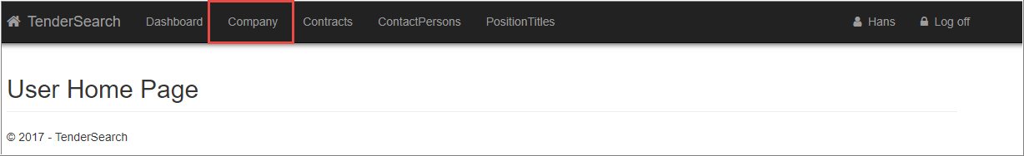

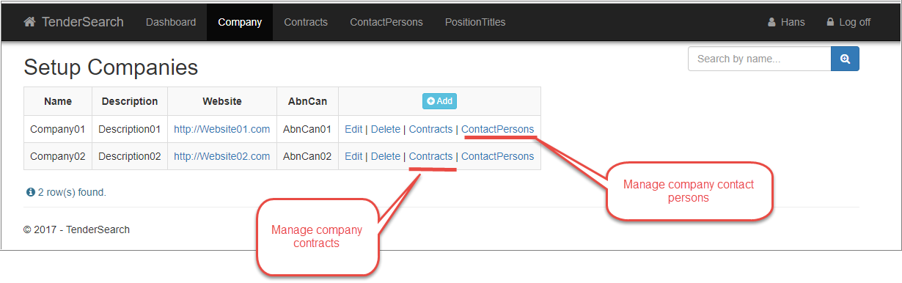 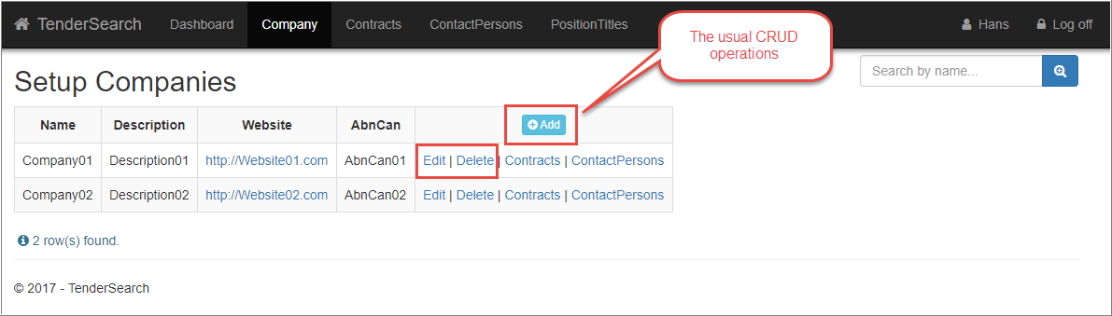

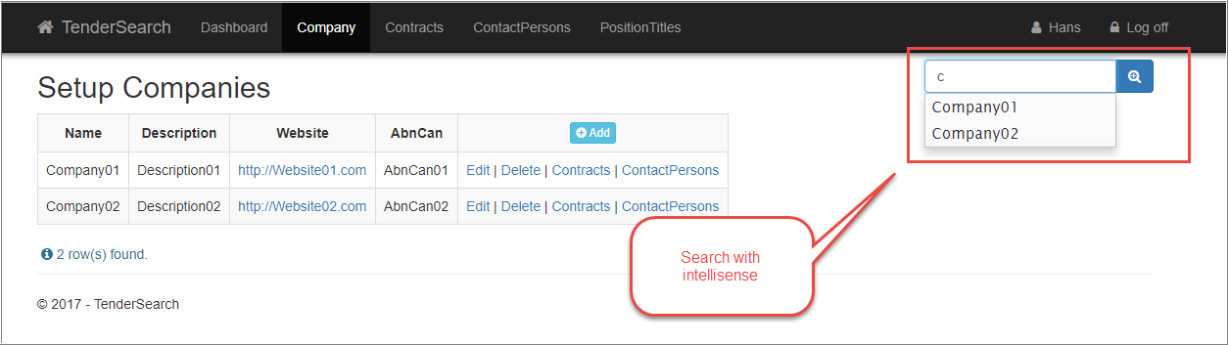

## Manage contracts

#### Expiration notification

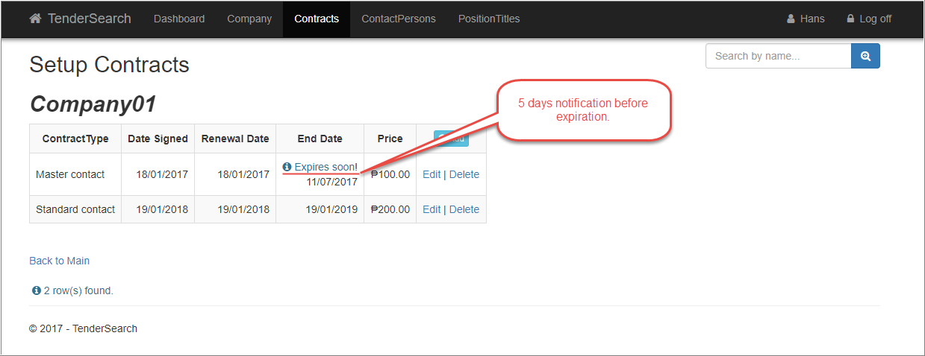

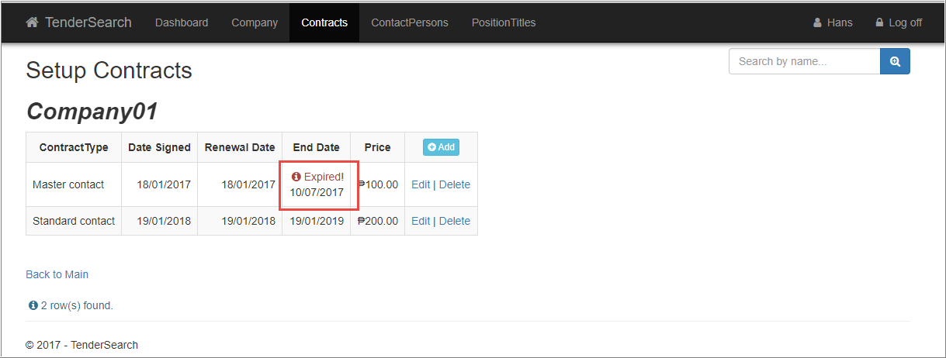

#### Check for invalid Contracts

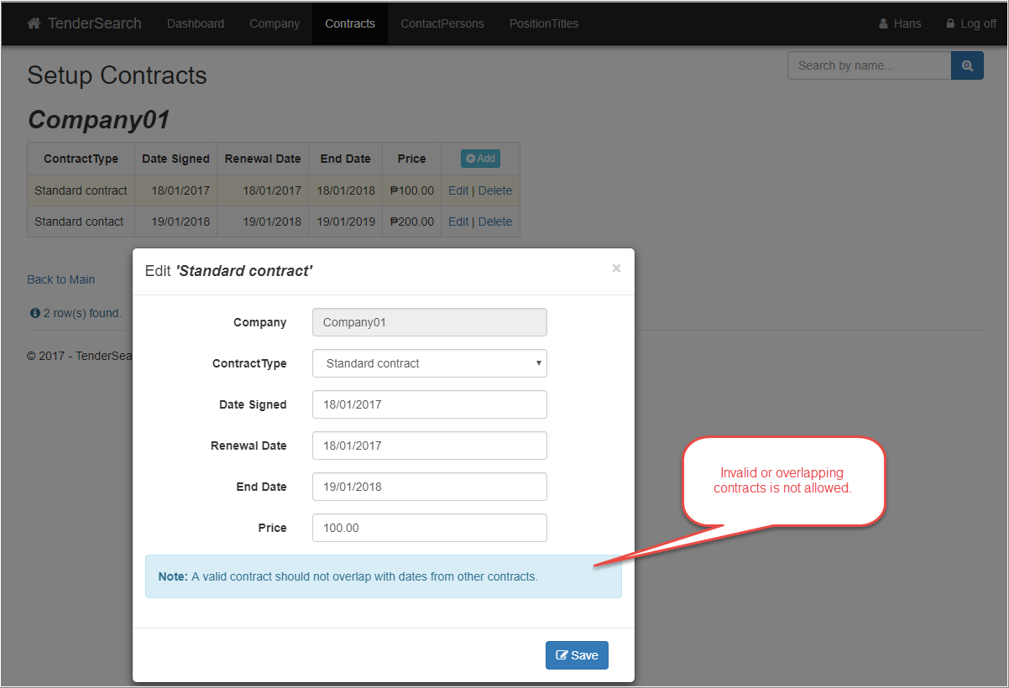

## Setup Contact persons

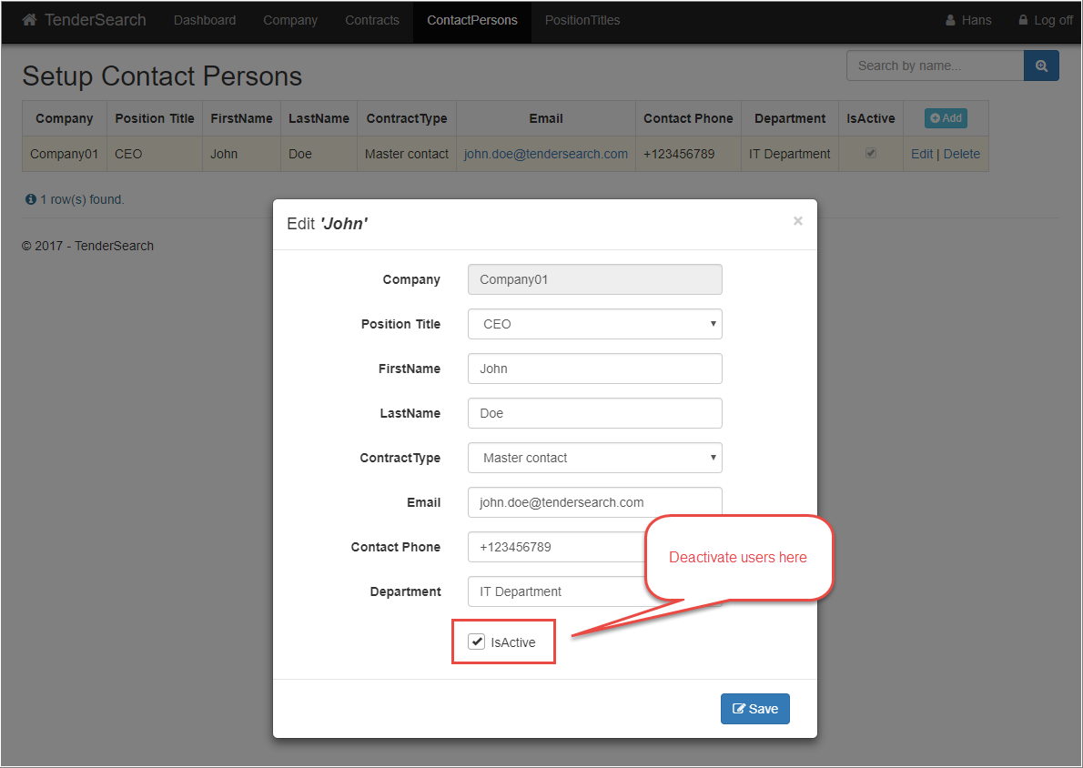

## Manage Position Tile

